Exercise 1 - Dawson

public class HelloWorld {

public static void main(String[] args) {

// TODO Auto-generated method stub

System.out.println("Hello World");

}

}

-Hello World

Exercise 2 - Dawson

public class HelloWorld {

public status void main(String[] args) {

// TODO Auto-generated method stub

System.out.println("Hello World")

}

}

-Error: Main method is not static in class HelloWorld, please define the main method as:

public static void main(String[] args)

Exercise 3 - Dawson

public class LoopExample {

public static void main(String[] args) {

int x;

for (x = 1; x <= 5; x++) {

System.out.print("Java ");

}

}

}

-Java Java Java Java Java

Exercise 4 - Dawson

public class LoopExample {

public static void main(String[] args) {

int count;

for (count = 1; count <= 5; count++) {

System.out.print("Java ");

}

}

}

-Java Java Java Java Java

Exercise 5 - Dawson

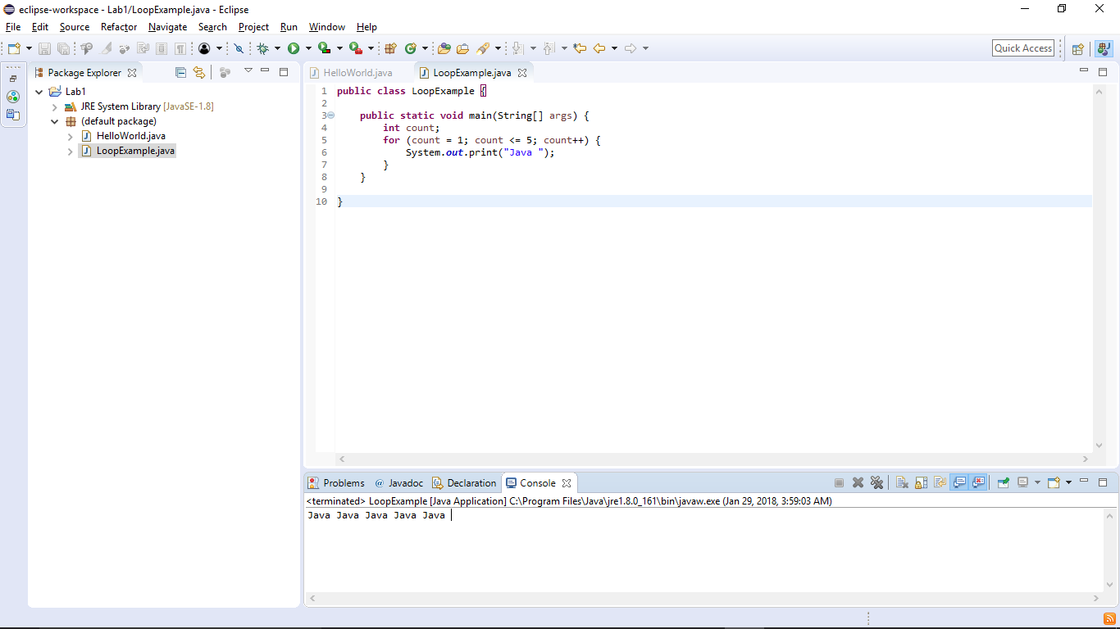

Exercise 6 - Dawson

I changed preferences.